(Approx. 1,663 words)

Home Networks
By Dick Maybach, Member, Brookdale Computer Users’ Group, NJ
July 2013 issue, BUG Bytes
www.bcug.com
n2nd (at) charter.net

Learning about networks, especially the Internet, can easily become mind-numbing, largely because the field is so full of jargon and acronyms. While it isn't possible to escape this morass completely, we can make it somewhat more manageable by approaching the topic in two stages: (1) a single computer connected to the Internet and (2) a home network connected to the Internet.

Every device connected to the Internet, no matter its location in the world, has a unique Internet Protocol (IP) Address. This is usually written as four three-digit numbers separated by periods, where the value of each number varies from 0 to 255. Although we usually think of a site's address as being its Uniform Resource Locator (URL), this is just a convenient representation. When you send a message to a URL, your computer uses a Domain Name System (DNS), usually a service provided by your Internet Service Provider (ISP), to find the associated IP address. For example, www.google.com is assigned the IP address 74.125.140.105. You, of course, must have your own IP address so that you can receive data. (You can find it by browsing the site http://whatismyipaddress.com/.) Your ISP assigns an IP address to your computer when you connect it to the Internet using a Dynamic Host Configuration Protocol (DHCP) service. This means that your ISP must own enough IP addresses to supply a unique one to each user, and normally each home users has only one. If you have only one computer and you plug it directly into the ISP's modem, this is sufficient.

Before introducing any more complexity, let's see what we can learn about our Internet connection. Use an Ethernet cable to connect your PC directly to the Wide Area Network (WAN) modem provided by your ISP. You will have to reboot your PC and probably the WAN modem to establish an Internet connection. If you use Windows, navigate through All Programs and Accessories to Command Prompt and type “ipconfig /all”. (The equivalent Linux and OS-X command is “ifconfig” or “ip”.) There are graphical programs that show the same information, but ipconfig puts it all on one screen. (The screenshot shows only the first portion the command's output.)
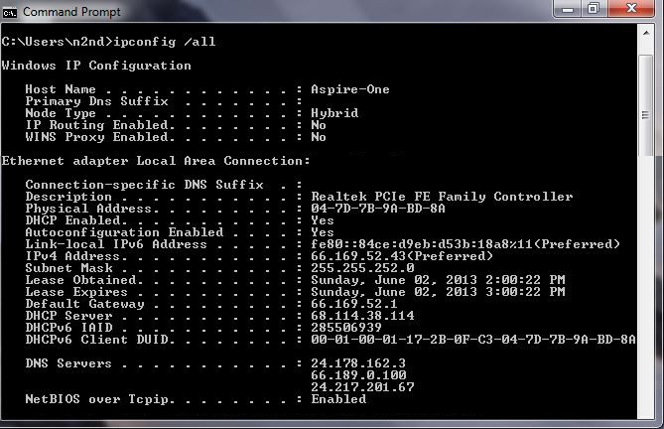
Fortunately, not all of the displayed data is important, but note the following items.
- DHCP is enabled and its server is located at 68.114.38.114, and the ISP hs used it to assign the IP address 66.169.52.43 to this particular PC.
- This address is valid for one hour (as shown by the Lease Obtained and Lease Expires times). Before the IP address lease expires, your PC will automatically request a renewal.
- The hard-wired address of the Ethernet interface in our PC is 04-7D-B-9A-BD-8A.
- One of the DNS servers at 24.178.162.3, 66.189.0.67, or 24.217.201.67 translates URL to IP addresses.
If ever you lose your Internet access, a good first step would be to repeat the above procedure to see whether the problem is in your home network or within your ISP.

However, many of us want to connect several devices to the Internet. How can we do this with only one IP address? There are blocks of IP addresses which never appear on the Internet, but are reserved for local use. The devices on most home networks use the addresses 192.168.1.x, where where x varies from 0 to 255. (The 1 in the third group could be replaced with any number from 0 to 255.) If your network is using the 192.168.1.x plan, it knows that any IP address in this range belongs to a local device and any IP address outside this range resides on the Internet. To make use of this, we purchase a router and connect our local network devices to it. It has a separate connector for a cable to our ISP's modem. The router, as its name suggests, directs any local messages to internal addresses and sends all others to the ISP, but first it changes their return address to the IP address the ISP has assigned. But this means that all incoming messages have the same IP address; how does the router get them to the correct local device? Each message has not only an IP address, but also a 16-bit port number, and the router changes the port numbers of the return addresses of outgoing messages. It keeps track of these and when an incoming message appears, changes its address to the appropriate local device and restores the original port number. This process is called Network Address Translation (NAT).
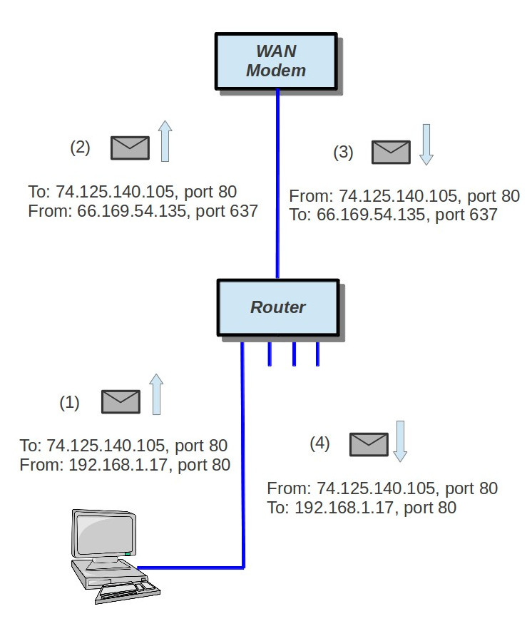
In the figure, our PC generates a message (1) to Google at 74.125.140.105 using Port 80. (It probably consulted an NDS to obtain Google's IP address.) In this case, the ISP has assigned us the IP address 66.169.54.135, and the router changes the return address to this (2) and changes the port to 637. When Google replies (3) to the only address and port it knows, the router consults its records and sees (4) that messages from Google to port 637 should be routed to local IP address 192.168.1.17 and Port 80. Your neighbor may also be using 192.169.1.17 as the local IP address for one of her PCs, but since her Internet IP address is not 66.169.54.135, she won't get your messages from Google.

If your home network includes a router, you should now reconnect it to the WAN modem and restore the original network connection for your PC. Again, use ipconfig /all (or ifconfig, as appropriate) and compare the results with those you obtained with the PC connected directly to the WAN modem. Again, the screenshot shows only the first portion of ipconfig's output.
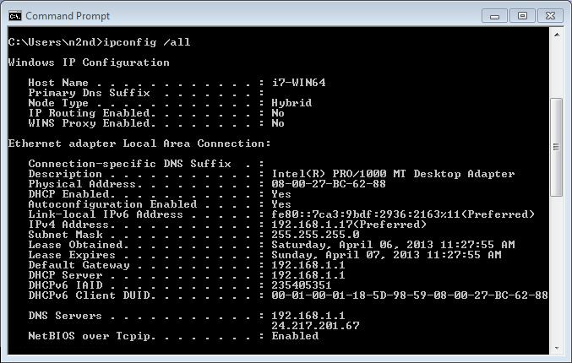
Note the changes. (Ignore the change of Host Name and physical address; this is for a different PC.)
- The IP address now begins with 192.168.1, which is a local one, as is the default gateway.
- The DHCP server is now our router, which assigns all the devices with IP addresses of the form 192.168.1.x.
- There are two DNS servers, one in the router for local devices and one at the ISP for the Internet. (Note that the latter is one of the three we saw when connected directly.)

Zenmap (http://nmap.org/zenmap/), available for Linux, OS X, and Windows, is a very valuable tool for exploring your local network. Pay special attention in the following discussion of how you can limit its probes to your local network, as its activities can look like you are trying to hack any computer it probes. Some system administrators are quite sensitive to these, and using them could result in unpleasant conversations with your ISP or legal authorities. The screenshot shows the results of a simple ping scan of my local network. Note that the target was 192.168.1.0/24. My network uses the addresses 192.168.1.x, where x varies from 0 to 255. Each field in the IP address is actually an 8-bit number, and the /24 tells Zenmap that it should not change the first three fields. (Three fields times 8 bits equals 24.) Thus it probes all the addresses from 192.168.1.0 through 192.168.1.255. If we had specified 192.168.0.0/16, Zenmap would have probed 192.168.0.0 through 192.168.255.255, and while this wouldn't probe outside your local network, it could take a long time. The result is shown below.
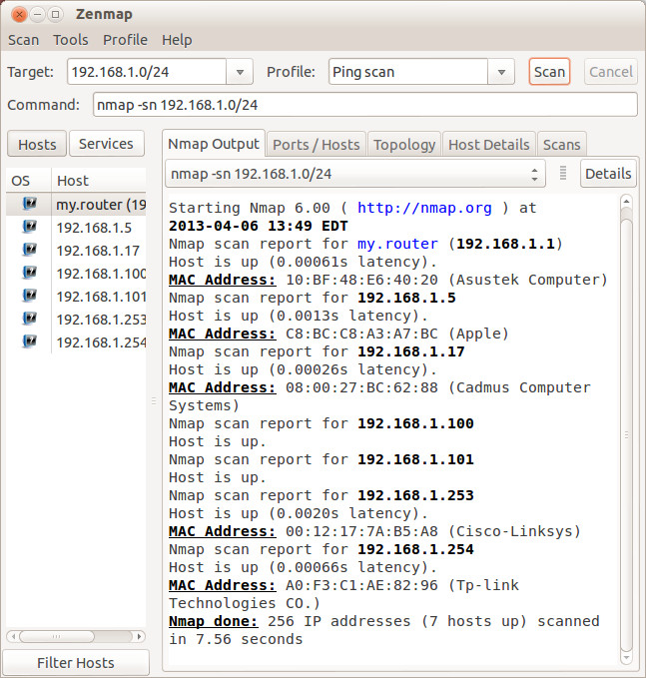
Seven devices are operating; since the first three fields of their IP addresses are the same, I'll designate them by only the last field. Our router is located at 1; 5 is a PC with an Asustek motherboard; 17 is a Windows 7 PC, 100 is the Ethernet adapter and 101 the wireless card of my desktop PC; 253 is a wireless access point; and 254 a network switch. A ping scan is quite simple; we are just looking for an answer from each address. We can learn much more by performing an intense scan, which takes several minutes, compared to the few seconds for a ping scan, and the results fill several screens. Fortunately, Zenmap can sumarize its results graphically.
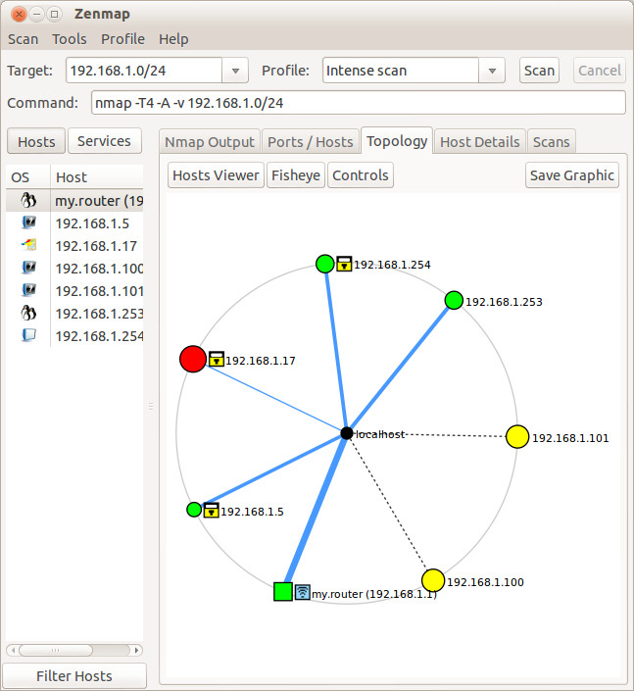
Circles indicate computers, and squares indicate routers. The colors and sizes of the nodes indicate how many ports are open; a greater number of open ports implies a greater vulnerability to outside hacking. (Green is good, yellow less so, and red could be something to be concerned about.) The thickness of the line to localhost indicates the round-trip delay; thick means slow. (I made this probe from the PC with addresses 100 and 101, so delays can't be measured here.) The square yellow icon is a padlock indocating that some of the ports are filtered, which lessens the vulnerability to hacking. Finally, the square blue icon indicates a wireless access point. (Clearly, the detection isn't perfect, because 253 is also a WAP.)

The host details tab shows what Zenmap has found about a particular computer.
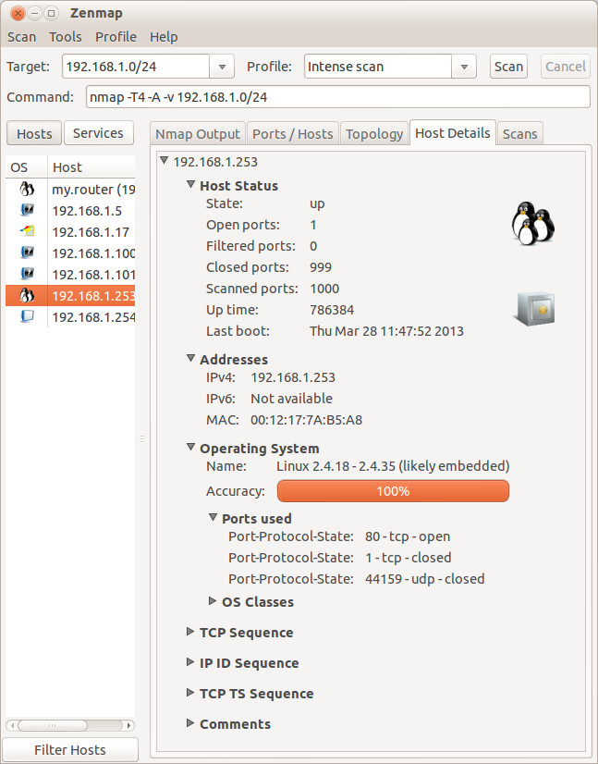
In this case (the WAP), the operating system is Linux and the one open port is 80.

Zenmap can also show you the route your data takes as it travels to its final destination. For example, let's again use www.google.com at 74.125.140.105. We enter this into the target box and select Quick traceroute as the scan. The screenshots show both the text and graphic results.
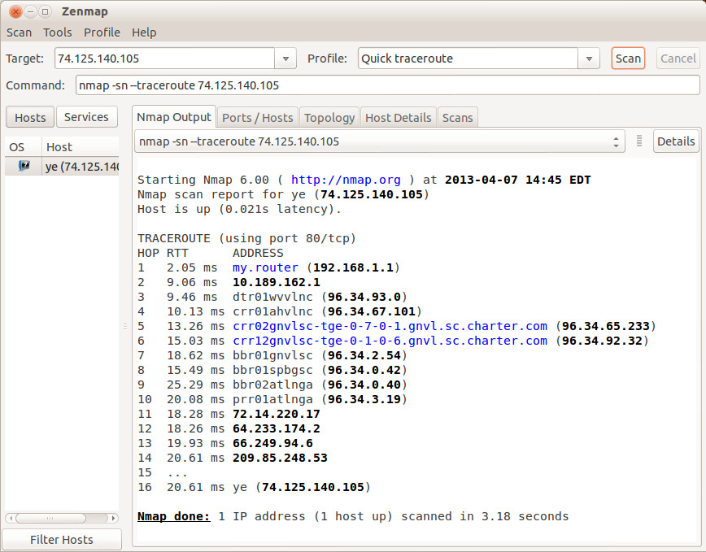
In this case, our test message made 16 hops on its way to Google, although other tests would provide slightly different results. You can also view these results graphically, but I find the text output easier to understand and to be more complete. There are other network tools, but Zenmap is included in the Parted Image toolkit (discussed in my April 2012 article, available at http://www.bcug.com.), which I always have it with me. There is extensive documentation for this useful program on the Zenmap Web site, accessible through the Help menu button visible in the screen-shots.

Taking a few minutes to explore your home network will remove much of its mystery and could prove valuable in solving future problems.

